Link for easy access:
https://one.uf.edu/soc/?category=%22CWSP%22&term=%222248%22&dept=%2260060000%22&course-code=%22aeb%22.
Click Expand all
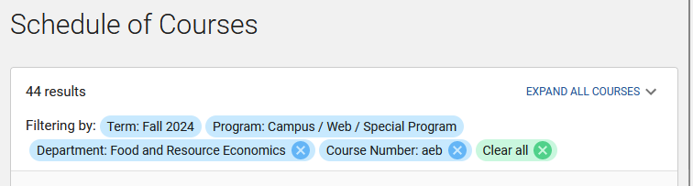
[CTRL] + F “shu”
Remove Danielle Shu (dshu@ufl.edu)
6 instances…
Replace with Trey Gifford Academic Advisor 1170A McCarty A 352-294-7640 agifford1@ufl.edu
This request was submitted 7/10/24.
Over 28 different people have read this request, and still it remains to be seen if anyone is able to help me. Last ticket listed at bottom, See Also, Tickets 1684??? 2951??? 4357???

All I am requesting is for the Advisor to be changed.
Thanks in advance for any assistance you are able to offer.
Dave
ddepatie@ufl.edu office 294.7641 cell 352.317.8297

https://ufl.teamdynamix.com/TDNext/Apps/34/Tickets/TicketDet.aspx?TicketID=1896

